**First Payment Reminder**

To whom it may concern,

Our records show that there is an outstanding payment due on this scheme.

We would appreciate if you could check this on your end and contact us within the next 7 days of the date of this letter to arrange payment of the outstanding amount.

To ensure that the members of your group scheme are always fully covered, it is very important that your premium is paid as soon as possible.

If the payment has already been sent, please disregard this notice.

If you have any questions, please contact us by calling the Corporate Accounts team on 01 5625303 (Monday–Friday,9am–5pm) or by email corporate.accounts@irishlifehealth.ie and we’d be happy to help.

Yours sincerely,

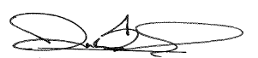

Darran Bennis

Senior Manager– Commercial Operations